Video tutorial:
- URL: https://www.udemy.com
- Username: scott.blankenship00@outlook.com
- Password: L^W3PylcaMtSdrM2

How to install Ubuntu Jammy (ver 22.04) server onto the raspberry pi zero 2W:
- Download the raspberry pi imager found here
- Once downloaded, run the program. A window should pop up that looks like the image below.
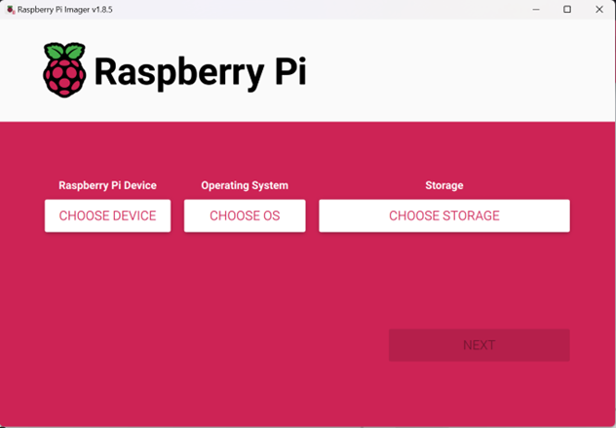
- Click choose device and select the Raspberry Pi being used for the device option.
- Click Choose OS and select Choose OS > Other General-purpose OS > Ubuntu > Ubuntu Server 22.04.3 LTS (64-bit)
- Make sure you choose the 64-bit because the 32 bit will not work with ROS2
- Make sure the Raspberry Pi SD card is inserted and choose the storage device under choose storage.
- Select next. And you will be asked to edit additional settings. Set up a unique host name. set the password to 12345. For consistency with the others.
- Set up the internet connection information. Change region to US. At the top select the middle tab and enable the SSH. Save and write. A warning may show that the drive is unavailable, just hit the x button (it works).
- Once the SD card is written the imager will automatically eject the drive. Remove the SD card then re-insert. A file system called system-boot should then show. Find the network config file and open it in notepad or any other basic text editor. You should see the WIFI SSID and Password that was typed in the imager. The password will be messed up, change it to the correct password making sure to keep the quotation marks.
- Eject the SD card and insert it into the raspberry pi.
- To find the IP address either plug the HDMI into the port on the pi and then power it on. Eventually the IPv4 will display, or just power on the pi and find the IP address from the router.

How to install Ros2 Humble:
The steps taken for this installation are written here. If confused, read the documentation.
- First we need to check if the locale supports UTF-8. In the ubuntu command line type the following command.
Locale
- If the following results all say UTF-8 your golden, proceed to the next step. If not use these commands:
sudo apt update && sudo apt install locales
sudo locale-gen en_US en_US.UTF-8
sudo update-locale LC_ALL=en_US.UTF-8 LANG=en_US.UTF-8
export LANG=en_US.UTF-8
Then check again with the “locale” command should all be UTF-8
- Now just copy and paste each line one at a time hitting enter in between. This will take a while for things to install so grab a cup of coffee and a good TikTok video.

sudo apt install software-properties-common

sudo add-apt-repository universe
sudo apt update && sudo apt install curl -y

sudo curl -sSL https://raw.githubusercontent.com/ros/rosdistro/master/ros.key -o /usr/share/keyrings/ros-archive-keyring.gpg

echo "deb [arch=$(dpkg --print-architecture) signed-by=/usr/share/keyrings/ros-archive-keyring.gpg] http://packages.ros.org/ros2/ubuntu $(. /etc/os-release && echo $UBUNTU_CODENAME) main" | sudo tee /etc/apt/sources.list.d/ros2.list > /dev/null

sudo apt update

sudo apt upgrade

sudo apt install ros-humble-ros-base (this version for desktop) sudo apt install ros-humble-desktop

- And that’s it, it should be installed. Again if you have any problems just follow the guide here. It does a lot more explaining and is way better than this tutorial.

Setting up Ros2 workspace and packages:

Workspace Setup, CD and ls command
- Once ROS is installed we need to check the installation directory and source the steup file for ros. This will allow the computer to know where ros is located.
- First check if there is a setup.bash file in using the following command.
ls /opt/ros/humble
- If the file is there run the following command.
source /opt/ros/humble/setup.bash
- To make it easier on ourselves we will write this into the root ./bashrc so that on startup the above command will always run and we don’t have to deal with it. To do this run the following command.
sudo nano ~/.bashrc
- This will pull up an editor for a bash file. Navigate to the bottom of the file and insert the following command.
source /opt/ros/humble/setup.bash
- Now this command will run every time the pi is set up and we don’t have to worry about it.
- Now make sure python3 is installed. This should be done already but if not run the following command.
sudo apt install python3
- Next install colcon, this is a package builder for ros2 and will be needed. To install, run the following command.
sudo apt install python3-colcon-common-extensions
- Once installed go to the following directory:
cd /usr/share/colcon_argcomplete/hook
- In this directory should be a file called colcon-argcomplete.bash. Using the same method above we need to source that bash file on every start up: this is done below using command:
sudo nano ~/.bashrc
- At the bottom below the source /opt/ros/humble/setup.bash command write the following command.
source /usr/share/colcon_argcomplete/hook/colcon-argcomplete.bash
- Now we are set up to start creating a ros2 workspace and packages. First we need to make a workspace directory for our ros packages. Do this by writing: mkdir ros2_ws. You can replace ros2_ws with any name but for our sake we are just going to use that.
- Open up the ros2_ws folder and make a new folder labeled src. Command line input: mkdir src. Once done use the colcon command to build the ros2 work space. To do this use the following command line input: colcon build. Now there should be 3 new folders along with the src folder.
- Open the root bash(sudo nano ~/.bashrc) once again and write the following source at the bottom of the script: source ~/ros2_ws/install/setup.bash

Setup python packages:
- Save and exit. Great now a ros2 workspace has been set up. To create a python package go to the src directory: cd ros2_ws/src
- Use the following command to build a python package:
ros2 pkg create <my_python_pkg> --build-type ament_python --dependencies rclpy
- Change <my_python_pkg> to some name you want. The Build type is specifying python and the dependencies are needed for ros2. Idrk
- For anytime in the future when you make a package make sure you source the install/setup.bash
- Now go to the ros2_ws folder and use either of the following commands:
colcon build
- This will compile every package in the ros2_ws folder.
Colcon build –packages-select my_py_pkg
- This will only compile the my_py_pkg
- If you get an stderr then most likely setuptools is deprecated fix this by using the following pip3 command:
pip3 install setuptools==58.2.0
- run the colcon command and it should work.

Setup C++ packages:
- Now let's learn how to set up a ros2 c++ package. Go to the workspace in the source folder.
cd ~/ros2_ws/src
- if you list the contents of this folder there should be previously made packages. To create a ros2 C++ package use the command bellow:
ros2 pkg create my_cpp_pkg --build-type ament_cmake --dependencies rclcpp
- now a C++ package has been created for our C++ code. We can use the following two commands to compile the package. First change the directory to just the ros2_ws
colcon build
- This will compile every package in the ros2_ws folder.
Colcon build –packages-select my_cpp_pkg
- This will only compile the my_cpp_pkg

Setting up Ros2 Nodes:

Create a Python Node.
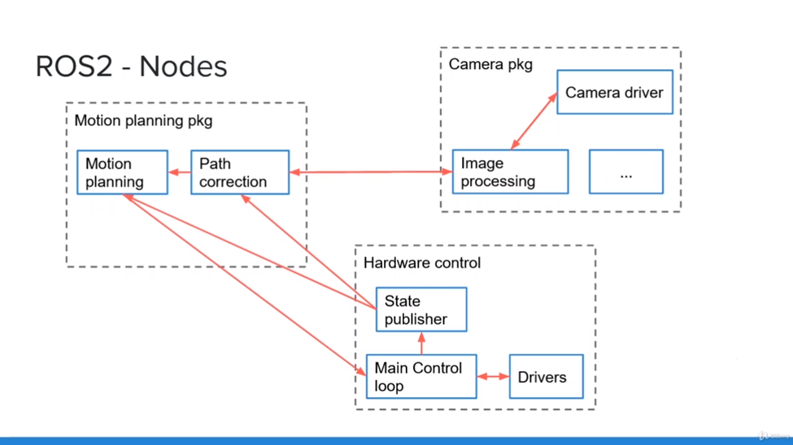
- First create a navigate to the folder that will contain all the node files the destination is: ~/ros2_ws/src/my_py_pkg/my_py_pkg

- To create a python file use the command: touch my_first_node.py
- Open the file with the desired editor (I just use nano if I am in the CL). Below is a basic setup for the python file with comments on what each line does.
#!/usr/bin/evn python3
import rclpy #Ros2 library for python. This is needed in every ros2 python script
from rclpy.node import Node

class MyNode(Node):
def __init__(self):
super().__init__("py_test")
self.counter_ = 0
self.get_logger.info("Hello Ros2")
self.create_timer(0.5, self.timer_callback)

def timer_callback(self):
self.counter_ += 1
self.get_logger().info(str(self.counter_))

def main(args=None):
rclpy.init(args=args) #starts ros2 communication
node = MyNode() #creates a node with the name python_test
rclpy.spin(node) # pauses the file and keeps the node alive. can be usefull for later
rclpy.shutdown #shutsdown ros2 communication

if __name__ == “__main__”:
main()

- Now we will install the file into the workspace for scalable functionalities. Open the setup.py file. This file should be in the following directory ~/ros2_ws/src/my_py_pkg.
- To the bottom of the file setup.py is the array console_scripts in the brackets. Below shows an example based on the script pasted above. The text called py_node will be the executable ran in the CL this should be unique. my_py_pkg is the package that the node is in my_first_node is the node and main is the function we want to run.
entry_points={
'console_scripts': [
"py_node = my_py_pkg.my_first_node:main"
]
}

- Go to the workspace directory (~/ros2_ws) and compile the file
Colcon build –packages-select my_py_pkg
- Now we can check where this node has been installed
- Most Likely in the directory: ~/ros2_ws/install/my_py_pkg/lib/my_py_pkg
- If you type ls, you should see the newly created py_node. You can run this node as well by using the following commands:
source ~/.bashrc
./py_node
- Now once the package I compiled, and the node is installed you can run the node using the command line a lot easier. It is best practice before running a package or node to runs the following CL. source ~/.bashrc then the node can be ran with the following code.
ros2 run my_py_pkg py_node

